Codes and Results

import pandas as pd

input = pd.read_csv('/kaggle/input/supermarket-sales/supermarket_sales - Sheet1.csv')

input.describe()

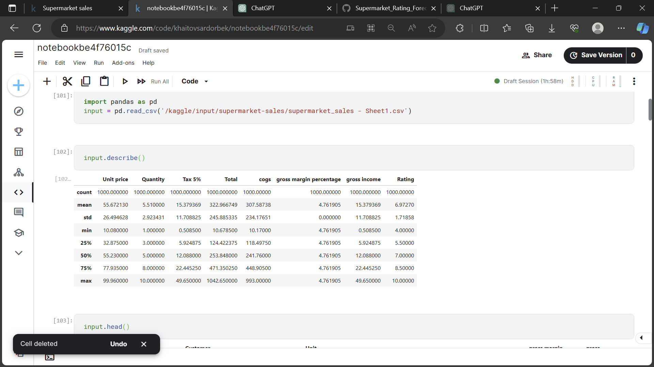

input.head()

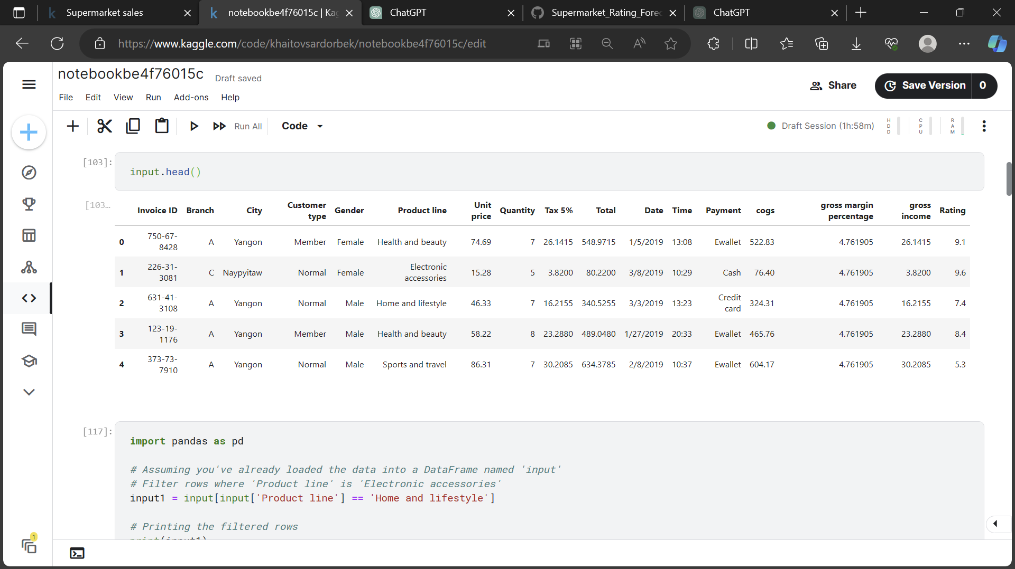

import pandas as pd

# Assuming you've already loaded the data into a DataFrame named 'input'

# Filter rows where 'Product line' is 'Electronic accessories'

input1 = input[input['Product line'] == 'Home and lifestyle']

# Printing the filtered rows

print(input1)

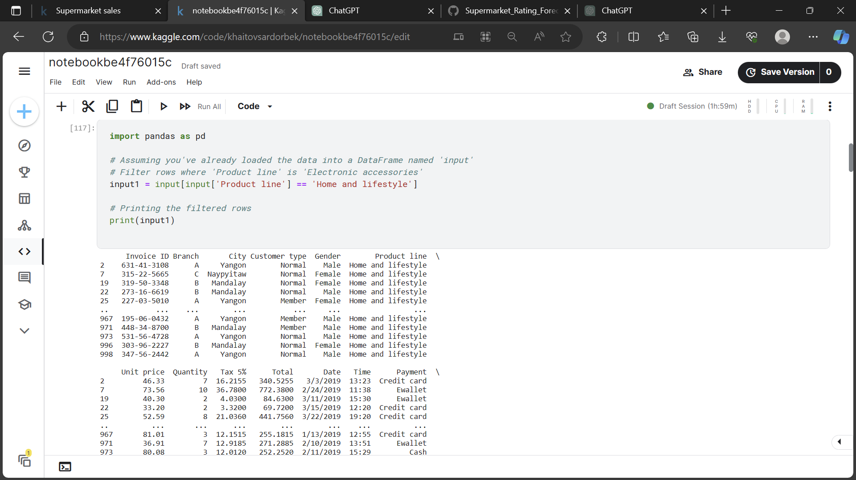

input1.describe()

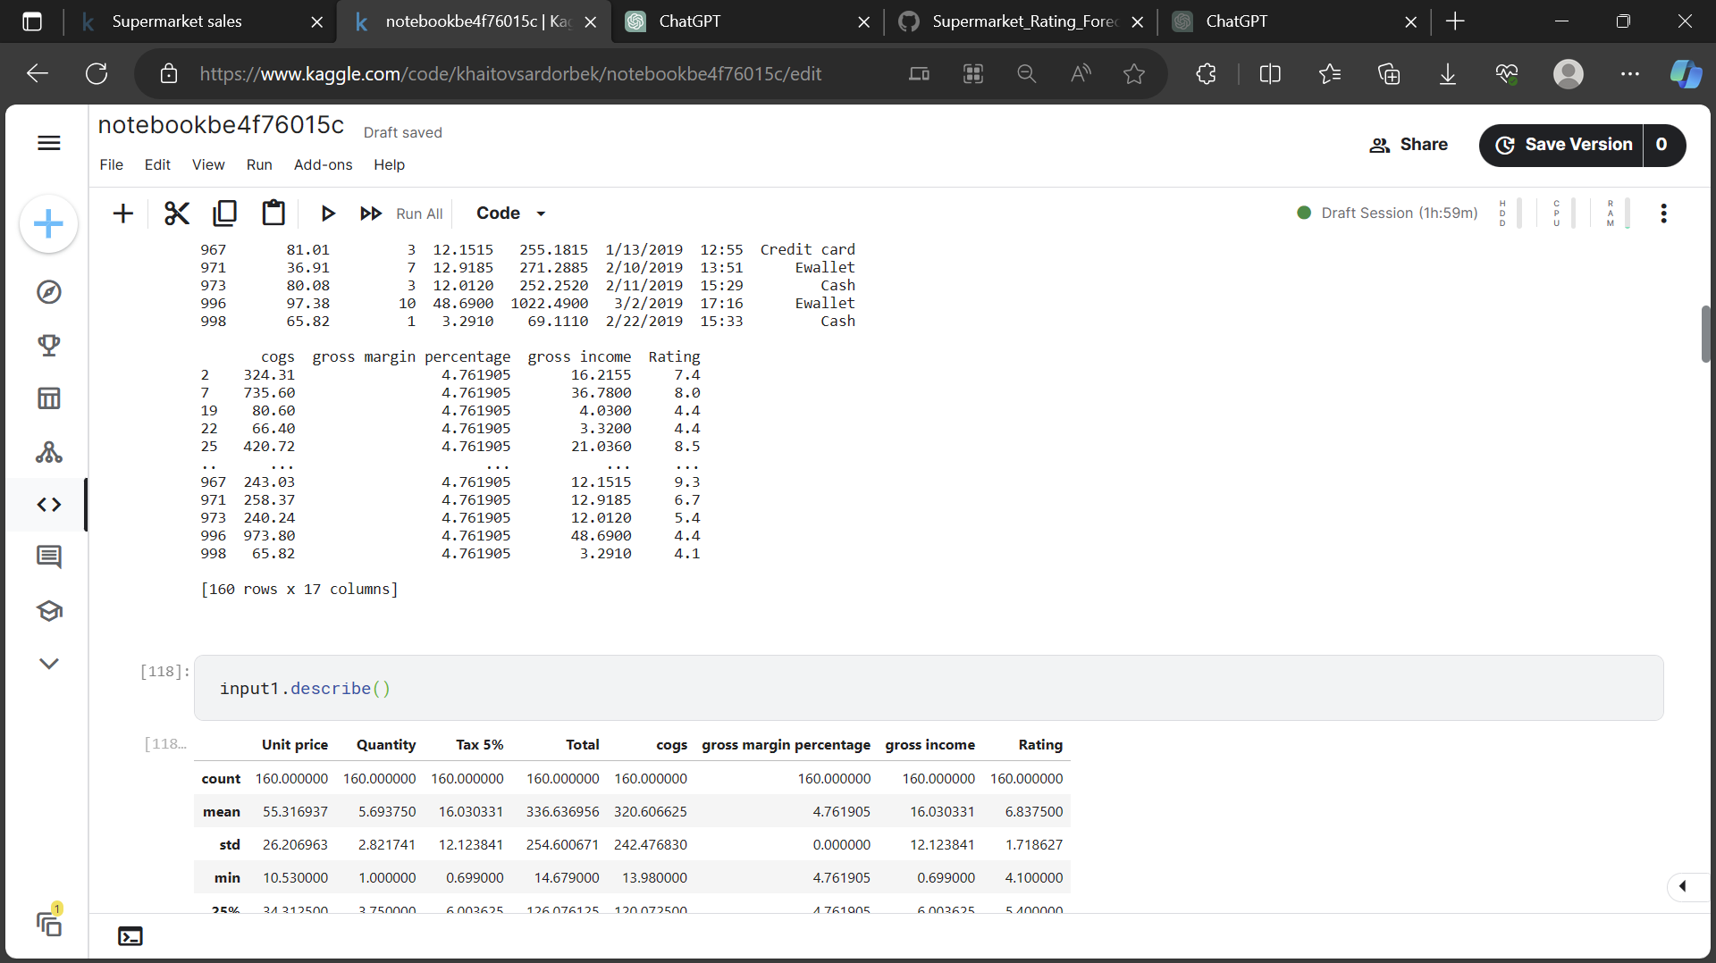

import pandas as pd

import matplotlib.pyplot as plt

import seaborn as sns

# Assuming 'input1' is your DataFrame

# Data Overview

print(input1.head())

print(input1.describe())

# Data Cleaning (if needed)

# Check for missing values: input1.isnull().sum()

# Handle missing values if any

# EDA

# Example: Plotting histograms

numeric_cols = ['Unit price', 'Quantity', 'Total']

for col in numeric_cols:

plt.figure(figsize=(6, 4))

sns.histplot(input1[col], kde=True)

plt.title(f'Distribution of {col}')

plt.show()

# Feature Engineering

# Extract information from Date and Time columns if needed

# Visualization

# Example: Correlation matrix

plt.figure(figsize=(8, 6))

sns.heatmap(input1.corr(), annot=True, cmap='coolwarm', fmt='.2f')

plt.title('Correlation Matrix')

plt.show()

# Insights

# Provide insights or recommendations based on the analysis

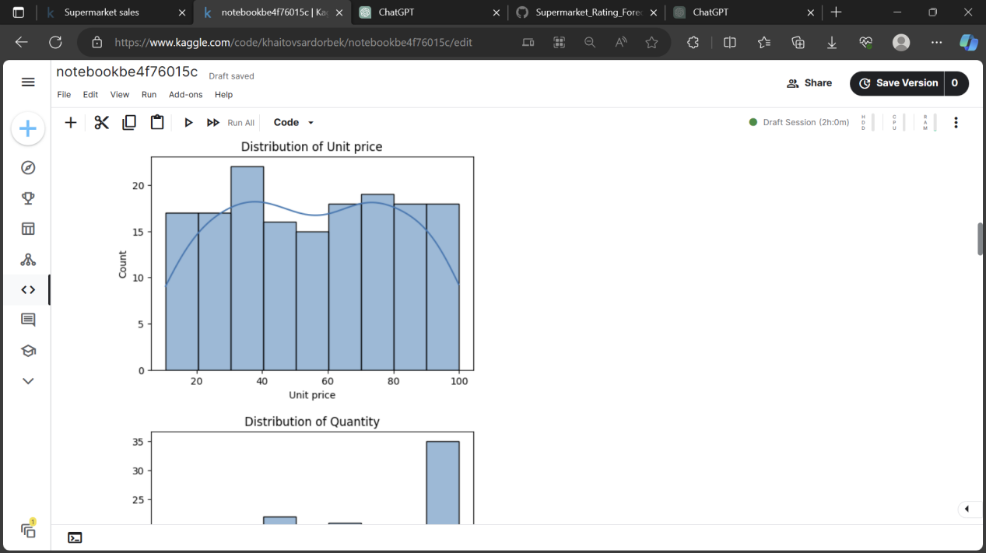

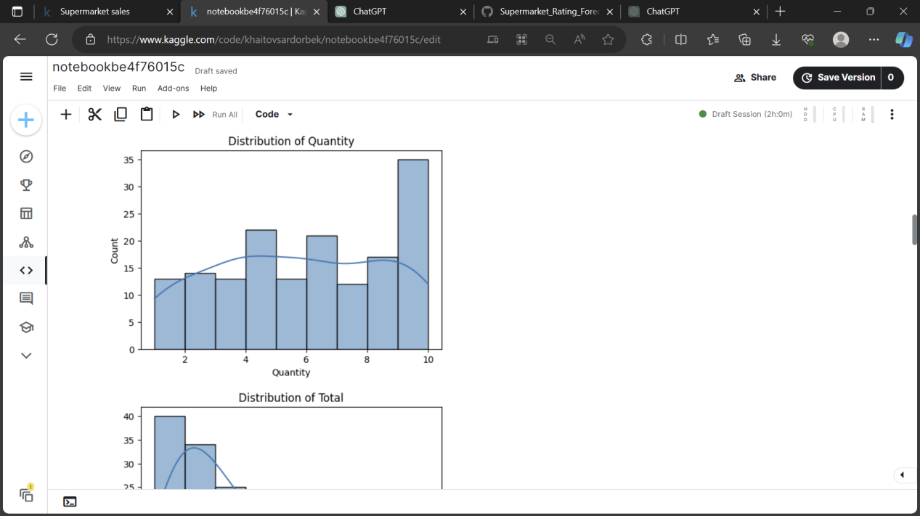

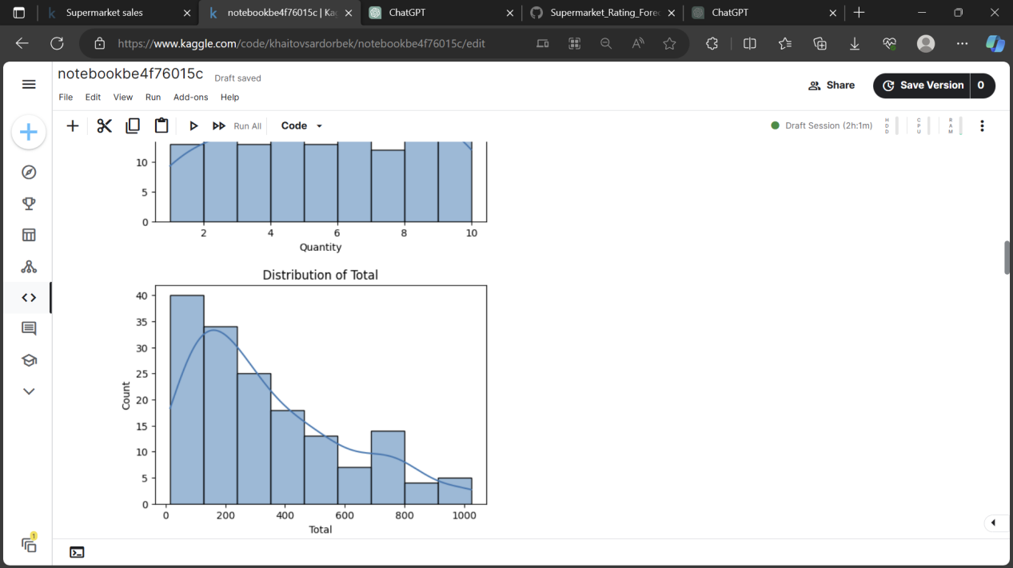

import pandas as pd

import matplotlib.pyplot as plt

import seaborn as sns

# Assuming 'input1' is your DataFrame

# Selecting only numeric columns for correlation matrix

numeric_cols = input1.select_dtypes(include=['float64', 'int64']).columns

# Compute correlation matrix for numeric columns

correlation_matrix = input1[numeric_cols].corr()

# Visualization - Correlation matrix

plt.figure(figsize=(8, 6))

sns.heatmap(correlation_matrix, annot=True, cmap='coolwarm', fmt='.2f')

plt.title('Correlation Matrix')

plt.show()

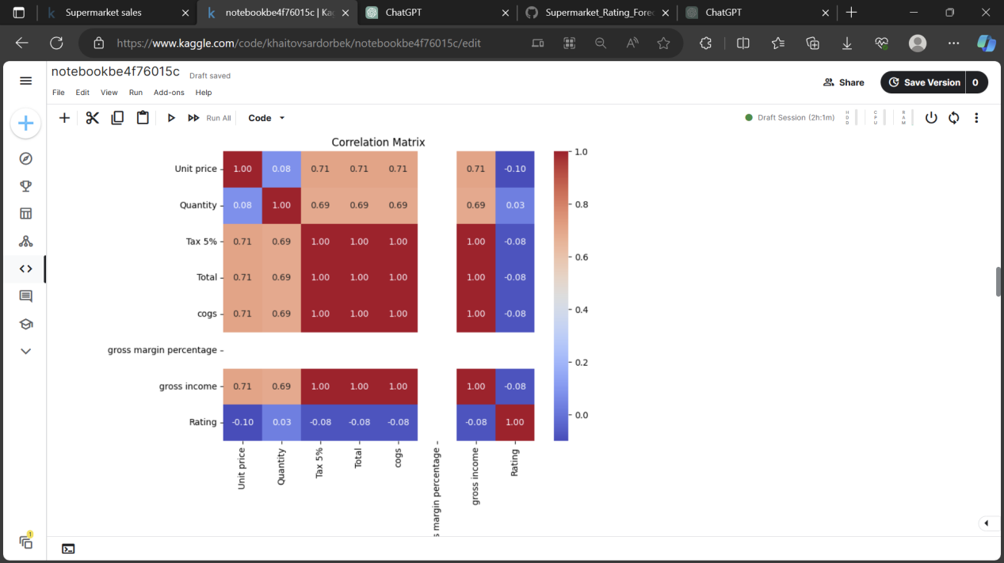

import pandas as pd

from sklearn.model_selection import train_test_split

from tensorflow.keras.models import Sequential

from tensorflow.keras.layers import GRU, Dense

from tensorflow.keras.preprocessing.sequence import pad_sequences

# Selecting the columns of interest

selected_columns = ['Quantity', 'Tax 5%', 'Total', 'cogs', 'gross margin percentage', 'gross income', 'Rating']

X = input1[selected_columns] # Features

# Target variable is 'Unit price'

y = input1['Unit price']

# Splitting the data into train and test sets

X_train, X_test, y_train, y_test = train_test_split(X, y, test_size=0.2, random_state=42)

# Building the GRU model

model = Sequential()

model.add(Dense(64, input_shape=(X_train.shape[1],))) # Dense layer

model.add(Dense(32)) # Additional Dense layer (optional

model.add(Dense(1)) # Output layer for regression

# Compile the model

model.compile(optimizer='adam', loss='mse') # Using mean squared error for regression

# Train the model

model.fit(X_train, y_train, epochs=100, batch_size=32, validation_data=(X_test, y_test))

# Evaluate the model

loss = model.evaluate(X_test, y_test)

print(f"Loss: {loss}")

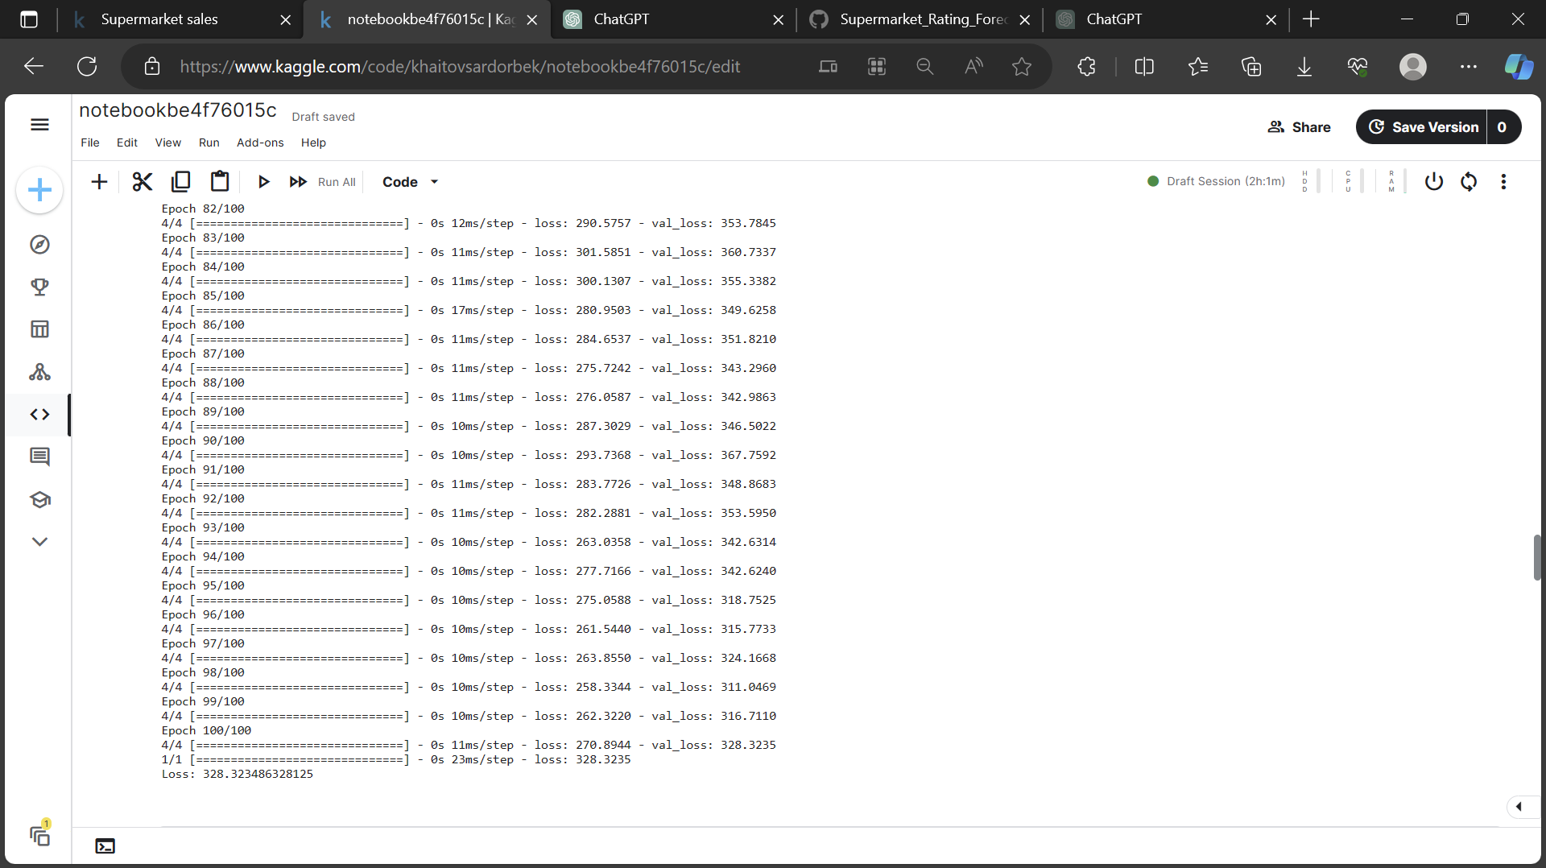

# Evaluate the model

loss = model.evaluate(X_test, y_test)

print(f"Loss: {loss}")

# Get model predictions

predictions = model.predict(X_test).flatten()

# Visualize actual vs predicted values

plt.scatter(y_test, predictions)

plt.xlabel('Actual Values')

plt.ylabel('Predicted Values')

plt.title('Actual vs Predicted Values')

plt.show()

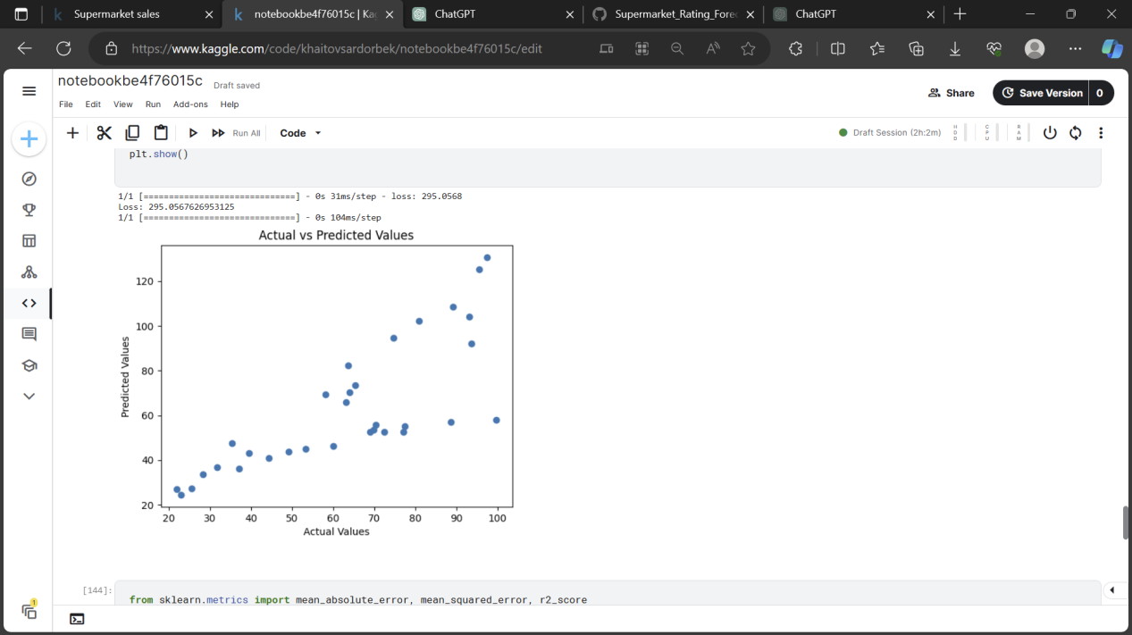

import matplotlib.pyplot as plt

import seaborn as sns

# Plotting for training set

plt.figure(figsize=(8, 6))

sns.scatterplot(x=y_train, y=train_predictions.flatten())

plt.xlabel('True Values')

plt.ylabel('Predictions')

plt.title('Training Set: True Values vs Predictions')

plt.show()

# Plotting for testing set

plt.figure(figsize=(8, 6))

sns.scatterplot(x=y_test, y=test_predictions.flatten())

plt.xlabel('True Values')

plt.ylabel('Predictions')

plt.title('Testing Set: True Values vs Predictions')

plt.show()

